**計算機程式設計HW11report 103061223李俊穎**

1. **Introduction of the problem and your solution**

The homework 11 is a “Small World Network with Information”. This time we need to add the student ID in the HW 10 code, and get the department from the ID to classify these students. Also, we have to find out the closest links between a student and another student neighbor which selected randomly and calculate how many trees do we need to find out all the students in the same department.

Because this time most of the codes have already been given, I just need to use a for loop to run all the students with a judge function. The following is my solution:

1. **Implementation details ,Additional features of your program (data structure, flows and algorithms)**

In the first step, I link all the students in random:

I link all the paths between two students:

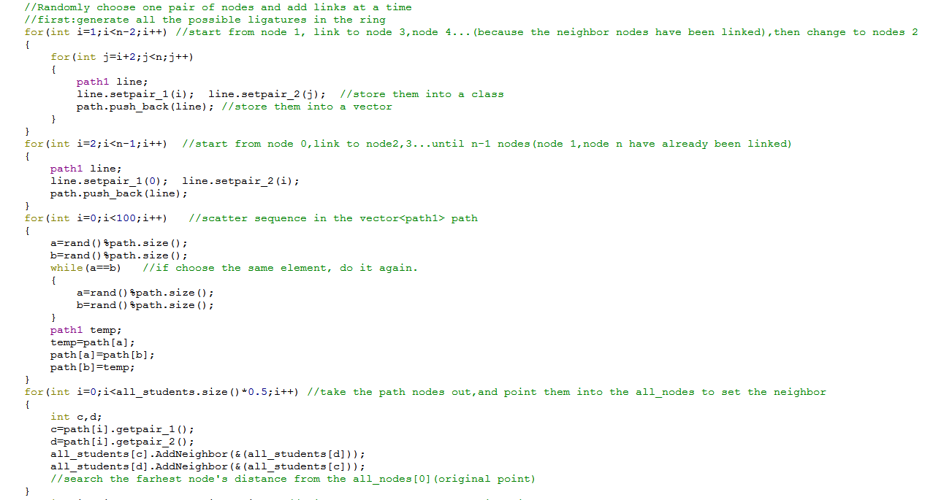

After producing all the links, store them into the vector with class type, and randomize them.

What this step does is add one pair of students, and in this part I print all the students’ ID:

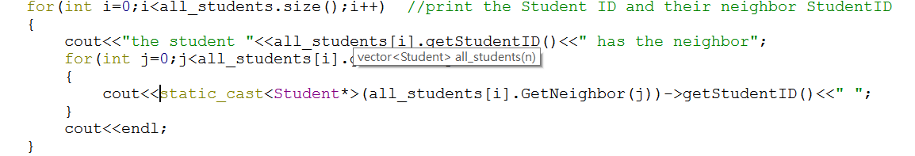

Second, I ask the user to choose which department do they want to search, and then use a for loop to scan all the students. If the student’s department is correct, the FindPathLengthsFromNode() will generate a tree from that student, and then tree++.

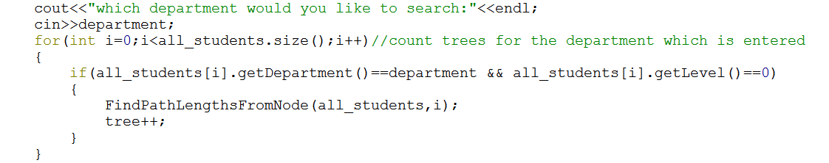

From the above we can calculate how many trees do we need to find out all the students in the same department.

The following is the function FindPathLengthsFromNode(), I pass the vector all_students by reference, so the data can be rewrite back to the class.

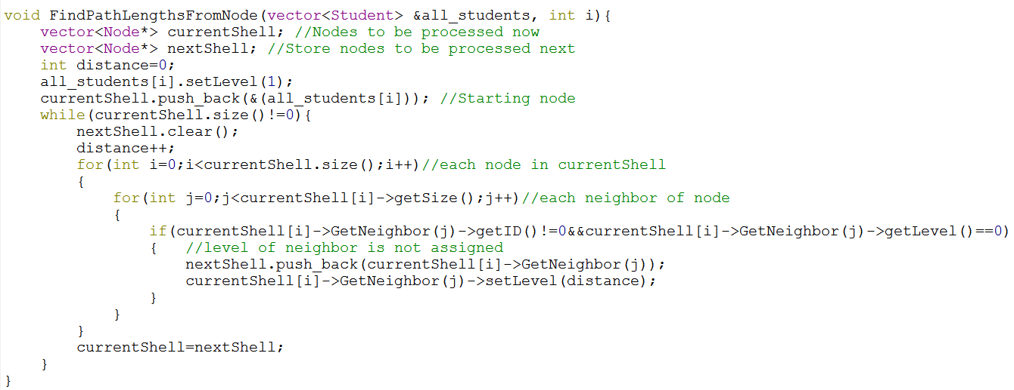

The extra thing I add is setting the start student’s level as 1 before the while loop, so every time I can check if this level of neighbor be assigned. If so, set the level with distance. By the way, because I set the original student’s level be 1, so in the following codes:

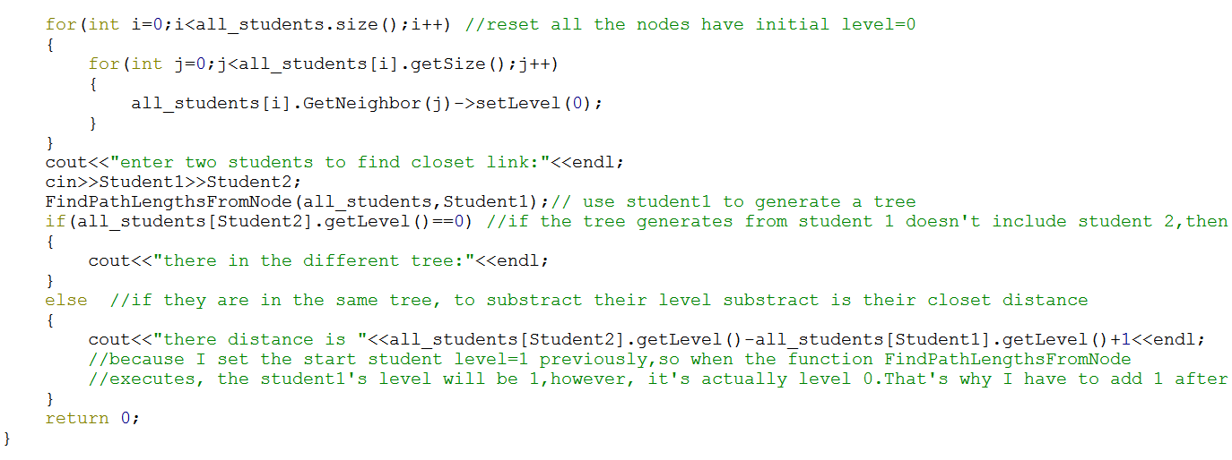

When I cout the closet distance, I have to add one back because the real level for the tree’s original student is level 0. If I just substract their level, the distance will reduce one. Then the result will be wrong.